HARVELELECTRIC ELECTRONIC STORE

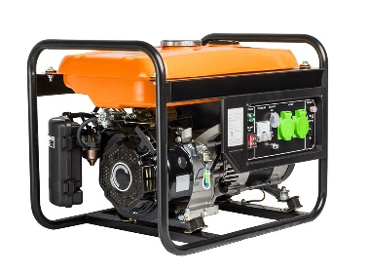

4.5kva Key Starter Big Generator SV6200E2

Brand: [Senwei](https://www.jumia.com.ng/senwei/)

**Price: $1650**

Was ~~$1700~~ 54%

+ shipping only for V.V.I.P clients.

## **Product details**

Ensure constant power supply in your home and office with the Senwei 4.5KVA Key Starter Generator - SV6200E2. It has a sturdy build and has been designed for consistently reliable performance.‎ This generator is ideal to use at any time of the day‎ thanks to its low noise operation.‎ It has a 4-stroke, single-cylinder engine type. It has a recoil manual and electrical starting system for extra convenience.‎ It will easily power your home and office appliances like televisions‎,‎ computers, printers and more.

It's so important to have the right home appliances, whether they are large or small, they help you through your day to day activities as well as make your standard of living a more comfortable one. Here at Jumia, there are HOME APPLIANCES to suit your all your daily needs. There are times when we are faced with power outage and in need of electricity to go about our daily activities, this is where our wide range of generators come in, our collection of SENWEI generators provide the ideal balance of affordability and durability. Providing you with the best products and services at the best prices.

The powerful SENWEI SV6200E2 4.5KVA Key Start Generator adopts an **advanced technology in design and performance** peculiar only to the SENWEI Brand.

**Product Specifications**

* Model: SV6200E2
* Brand: SENWEI
* AC Frequency: 50 Hz
* Starting Capacity: 4.5KVA
* Running Capacity: 4.2KVA
* Alternator Type: Brushless, self exciting, synchronous, 2-pole,  Enameled Wire
* Voltage Regulation: 220V
* Phase: Single Phase
* Engine Type: 4-stroke single cylinder, OHV, air cooled
* DC Output ): 12V/8.3A
* Starting System: Electric / Recoil (Manual) Aluminium coil
* Fuel: Petrol
* Fuel Tank Capacity: 15L
* Battery: Yes
* Tyres: Yes
* Noise Level @ 7 Meters: 68 dB
* Dimensions (LxWxH): 715*460*460
* Weight: 55 KG

## **Specifications**

## **KEY FEATURES**

* Key Start
* AC Frequency: 50 Hz
* Starting Capacity: 4.5KVA
* Running Capacity: 4.2KVA
* Alternator Type: Brushless, self exciting, synchronous, 2-pole

## **WHAT’S IN THE BOX**

* Generator instruction
* Handle and tyres
* Battery.

## **SPECIFICATIONS**

* **SKU**: SE859GP1H4DX0NAFAMZ
* **Product Line**: Real world
* **Model**: Sv6200E2
* **Weight (kg)**: 50
* **Color**: Yellow